Year 6 Autumn Newsletter

Welcome back! I hope you have all had a lovely summer break and are ready for the new school year. I am very excited for the year ahead with and our new year sixes are already proving to be fantastic role models. The children have settled in very well in their first week back and have returned to school with a hard-working, positive attitude. This year we will be appointing a new head boy and head girl, application forms will be sent out soon – I can’t wait to find out who the successful candidates will be!

Are we stronger together?

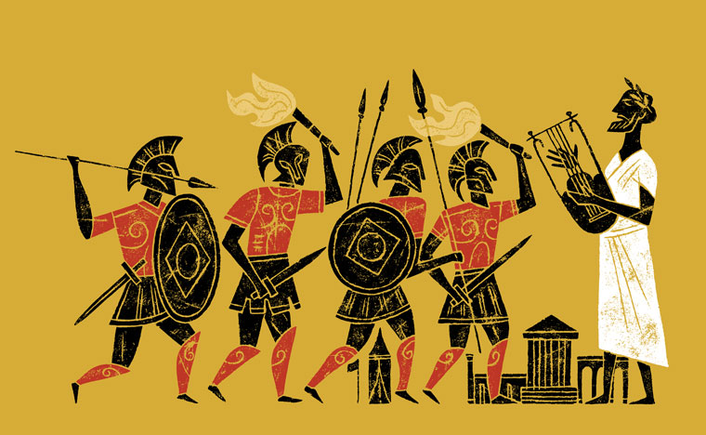

This term we will be exploring our enquiry question through learning about World Wars 1 and 2 as well as looking at present day conflict.

In history, we will be learning about key events and people during WW1 and WW2 such as the Battle of Britain, the Holocaust and The Battle of Dunkirk. We will also consider the impact this conflict had on everybody involved, including children.

In geography, we will be learning about the importance of trade links between different countries and the importance of industrial areas and ports. We will also learn about the distribution of natural resources such as food, water, energy and minerals.

In D&T, after drawing detailed 3D designs of a house, we will be selecting and using the correct tools to build it. Black-out curtains will be essential if it has any chance of surviving the Blitz later in the term!

Our Enquiry question this term is:
Is conflict every justified?
This term we will have a daily focus on arithmetic. This half term, we will be building on our understanding of place value by exploring numbers up to ten million. We will also be learning to use the four operations (addition, subtraction, multiplication and division).
Next half term, our learning will focus on fractions.

***Please remember to keep practising times tables on TTRS, having automaticity of these facts is invaluable when solving mathematic questions at speed***

Our PE lessons are going to be taught on a Tuesday afternoon. Please make sure your child arrives at school on a Tuesday wearing their PE kit. PE kit expectations can be found on our school website.

Writing

In our writing sessions we are going to be writing a diary entry from the perspective of a soldier on the front line in WW1 and as a WW2 child evacuee. We will use ‘The Piano’ to write a flashback narrative. To summarise all our learning, at the end of term we will be writing a non-chronological report based on our enquiry.
We will also have daily, additional grammar and spelling sessions.
***Please ensure your child is accessing spelling shed throughout the week***

Reading

During reading sessions, pupils will work independently as well as part of a group to develop and improve the skills to read and understand a range of text types. The expectation is that children read at least three times a week at home. Our class book this term is ‘Letters from the Lighthouse,’ a historical fiction book based during WW2.
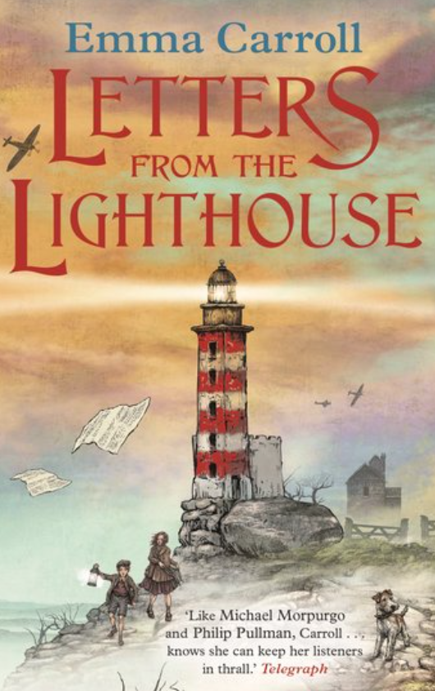

Please feel free to contact me if you have any questions or concerns through ClassDojo.

Class Teacher Headteacher
Miss Miller Mrs Smith

