Foundation Autumn 1 Newsletter

We would like to say a big welcome to all of our new families and those of you who are returning to us. This first week has been lovely, it’s been a pleasure to get to know you all and we’re really looking forward to spending the year with you.
Meet the team:
​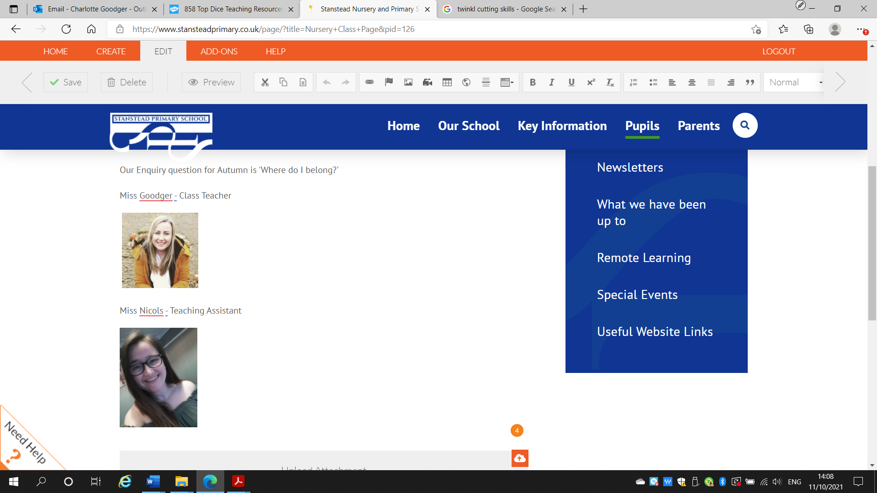Miss Goodger (Nursery Teacher) Miss Nicolls (Nursery TA)
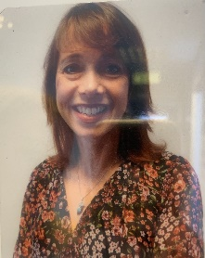Mrs Foxall (Reception Teacher) 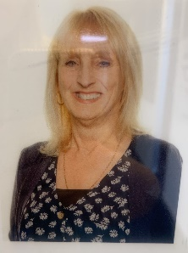Mrs Matto (Reception TA)
This term’s topic:
This term our enquiry question is ‘Where do I belong?’. We will spend the time getting to know each other, learning the routine, making friendships and finding out what makes us unique. Each week we will use a quality text to support our learning.
Week 1 | Week 2/3 | Week 4/5 | Week 6/7
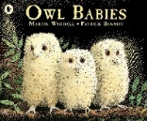  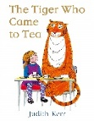  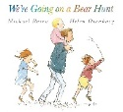 | 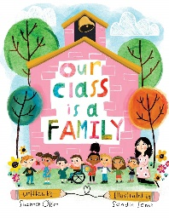 | 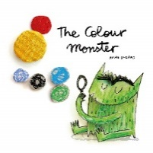  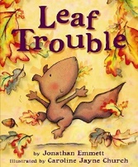 | 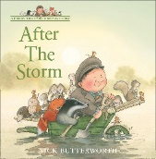  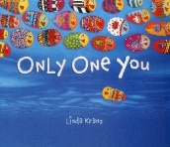


Reading Books:
All children now have a reading diary and a school book. In Nursery this will be a picture book and in Reception we will start with a picture book and progress to a book with words as we teach our Phonics sessions. In addition to this we will send home a daily phonics practise sheet.

How you can help your child with their learning at home:

- Encourage your child to dress independently - teach them how to do up their buttons, zips, buckles, put on/take off their jumpers.
- Encourage physical activity through trips to the park, ball games, swimming, running, biking, climbing, etc.
- Read with your child each night, discuss the story with them and have fun!
- Encourage your child to talk about what they do at school each day.
- Look for and discuss different sounds around the home, and when out and about.
- Look for numbers and shapes in the environment as you are out and about.
- Count regularly with your child - as they are tidying up, doing different jobs.

Kind Regards
Miss Goodger (Nursery Teacher)
Mrs Foxall (Reception Teacher and EYFS Lead)

