Stanstead Nursery and Flying High Academy School


__________________

SEN Information Report 2025-2026

Stanstead Flying High Academy is a mainstream school with an inclusive ethos. We have high aspirations for all pupils and so we strive to offer the best possible teaching and support both to our children and their parents and pride ourselves on having open approachable access to all.
All Trust schools are supported to be as inclusive as possible and support pupils with Special Educational Needs and/or Disabilities in mainstream settings wherever possible. We support children with the four main areas of need, which are:
- Cognition and Learning
- Communication and Interaction
- Social, Emotional and Mental Health Difficulties
- Sensory and Physical
At Stanstead Flying High Academy we believe that all children should be valued equally within a climate of warmth and support in which all pupils feel valued and able to risk making mistakes as they learn without fear of criticism. We want all our SEN children to “Make every moment count”.
The ability to form good relationships with pupils, to plan interesting lessons scaffolded to appropriate levels, to implement a consistent behaviour policy and to give praise, encouragement and other constructive criticism, are all part of the provision of effective teaching of all pupils but especially those who have special educational needs.
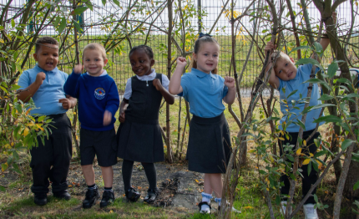

Training
We recognise the need to train all staff on SEN issues so we aim to keep all school staff up to date with relevant training and developments in teaching practice in relation to the needs of pupils with SEN. The SENCo attends relevant SEN courses, Trust SENCO Update training and facilitates/ signposts relevant SEN focused external training opportunities for staff, who cascades information back to staff. The SENCo, with the Senior Leadership Team, ensures training opportunities are matched to school development priorities and those identified through provision mapping.

Training



Meet the Inclusion Team
school and life. He supports children with managing emotions, building self-esteem, developing friendships, coping with loss or change, and improving problem-solving skills, through planned, small-group or one-to-one sessions in a safe and supportive environment.

ELSA

Will Smee is our ELSA (Emotional Literacy Support Assistant) who helps children develop emotional and social skills so they can succeed in school and life. He supports children with managing emotions, building self-esteem, developing friendships, coping with loss or change, and improving problem-solving skills, through planned, small-group or one-to-one sessions in a safe and supportive environment.

SENCO

The school’s SENCO is Victoria Blair. She has dedicated time to support the needs of children with SEND and their families through meeting with parents, observing children, liaising with outside agencies, planning provision and monitoring the impact of the provision.
families through meeting with parents, observing children, liaising with outside agencies, planning provision and monitoring the impact of the provision.

Training
Staff within the school have had recent training in:
- Using signs and symbols to aid communication from SALT for specific individuals
- Makaton
- Safeguarding
- Scaffolding
- No nonsense phonics
- Intensive interaction
- Attention Autism
- Supporting developments of highly personalised provision through visits to other settings, Trust update meetings and monitoring
- Reading bench marking
- Routes to Inclusion

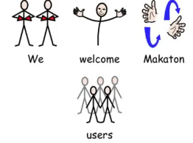

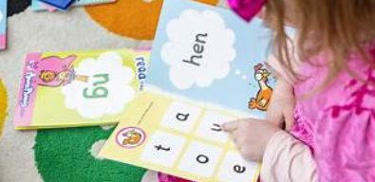

How we identify people with SEND
We use a variety of ways, often more than one including:
- Liaison with the previous school or setting
- Regular assessments, identifying those making less than expected progress, either by age or individual circumstance
- Concerns raised by parents
- Concerns raised by the class teacher
- Using standardised assessments e.g. NTS
- Liaison with outside agencies e.g. Health, Local Authority Schools and Families Specialist Support Service
- Pupils with EHCPs or EHAFs have their needs identified on their plans including strategies to support them

‘Providers must have arrangements in place to support children with SEN or disabilities. These arrangements should include a clear approach to identifying and responding to SEN. The benefits of early identification are widely recognised – identifying need at the earliest point, and then making effective provision, improves long-term outcomes for children.’ (Department for Education, 2014, 5.4, SEND Code of Practice: 0-25 years)




What can parents do if they have concerns about their child?

Talk to the class teacher in the first instance as “All teachers are teachers of SEND” COP 2015

Make an appointment with the SENCo (Victoria Blair) or the Head Teacher (Tanya Smith) by going to the School Office or by phone on 0115 9156300

Email senco@stanstead.nottingham.co.uk

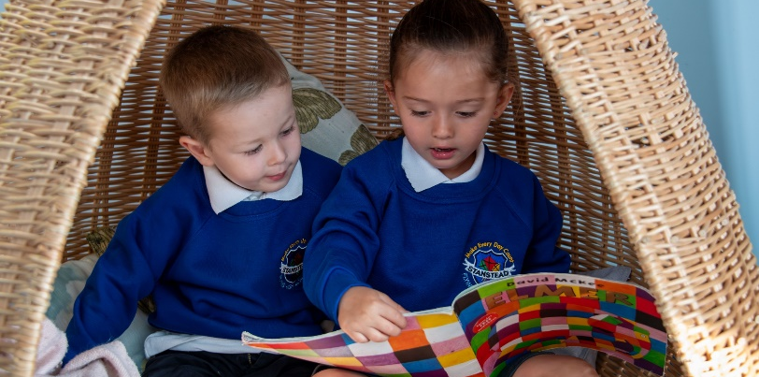
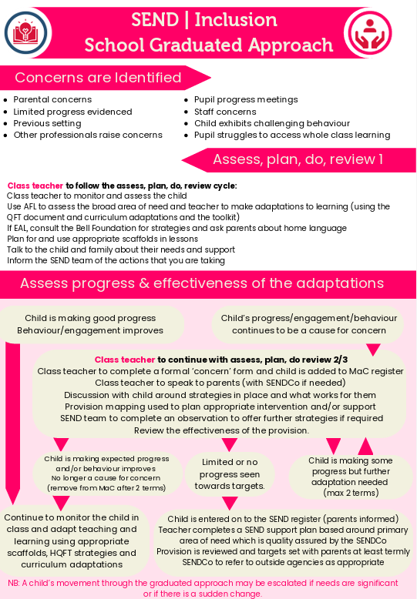
How do we support children with SEND?
How do we adapt our curriculum and environment for our children?
High quality teaching, scaffolded for individual pupils, is the first step in responding to pupils who have or may have a special educational need. Below are some approaches we might take. This list is not exhaustive, and adaptations will be made in line with individual children’s needs. These adaptations allow children with SEND to fully participate in school life alongside their peers. If children access nurture spaces or intervention groups, they will have times planned to work alongside their peers in their classrooms, maintaining a feeling of belonging with their peers. Any plans like this, will be discussed with parents.
Adaptations to the Curriculum
Ensuring the child’s strengths are used to build confidence, self-esteem and maintain motivation
Using a multi-sensory approach to give pupils the opportunity to learn effectively in a way suited to them and their current stage of development

Using a clearly defined step-by-step approach promoting gradual development of concepts and skills

Allowing work recorded in alternative formats

Providing low sensory spaces
Structuring play times
Using dual coding (images alongside words) to support learning of vocabulary

Providing pre-teaching opportunities to increase confidence and post-teaching to reinforce learning
Allowing sufficient repetition to consolidate skills

Supplementing information in books with audio, video, pictures, charts, diagrams
Providing sensory regulating resources

Wave 1 | Inclusive high-quality teaching for all, providing scaffolded work and creating an inclusive learning environment.
Wave 2 | Specific, time limited additional measures for some children who need help to work at or above age-related expectations. These children are on our ‘School Concern’ register.
Wave 3 | Additional highly personalised interventions. These children are on our ‘SEN Support’ register.
Waves of Intervention

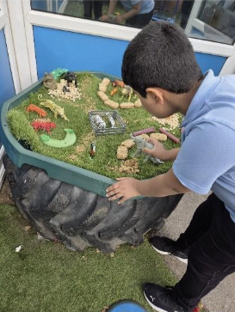

Starshine Enhanced Provision
At Stanstead, we have Starshine, our enhanced provision. Starshine focuses on meeting the Communication and Interaction needs of pupils with, or on the pathway to Education, Health and Care Plans (EHCPs). For some children, it provides a gradual, well-supported transition into specialist education; for others, it offers a pathway back into mainstream learning when this becomes the most suitable option. These decisions are made collaboratively with families, the school team, and external professionals, and are revisited regularly through the Graduated Approach and EHCP review processes.

The provision is delivered by skilled staff with specialist training, ensuring that each pupil receives tailored support informed by high-quality practice.

Through this approach, Starshine creates a nurturing, high-expectation environment where children are supported to flourish, succeed, and move forward confidently into the next phase of their education.

Supporting children with Emotional and Behavioural Needs (SEMH)
We recognise that some children may need extra support and guidance at some point with their emotional and behavioural development. We have a graduated response in place to support such children.
  - The Class Teacher has overall responsibility for all children in their class.
  - Children receive PSHE lessons – Using the Jigsaw programme of study- as part of our curriculum in which issues of friendship, relationships and behaviour are explored.
  - We ensure children tackle issues such as bullying, health and economic wellbeing in a whole class supportive framework.
  - The school has a nurture room and fully qualified ELSA teacher
  - We have a wide range of nurture interventions which can be offered to children to support their social and emotional wellbeing, such as cooking, craft, health and hygiene, blob tree, humunculli
  - Evidence of the child’s SEMH needs will be collated to identify potential barriers and triggers for behaviours via Routes to inclusion assessments and / Boxall profiling
  - Children with significant behavioural difficulties will have their provision added to their SEND support plan and additional meetings and reviews added where appropriate
  - A group / class workshop with the Mental Health Support Team (MHST) may be offered if the school feels it would be beneficial to the class.
  - If we feel that the in-school graduated response has not been sufficient, we may (with the consent of parents) involve a child counsellor and 1:1 MHST referral if appropriate.



Consulting with Parents and Young People with SEND

Parents are an integral part of decision-making processes. For parents, this communication occurs through:
- Reading diaries
- Regular face-to-face contact with class teachers at the start and end of the day
- Termly parents’ evenings
- SEND Review Meetings
- The annual school report
- School newsletter
- ELSA lead conversations
- Annual SEND parent questionnaire

For pupils, this communication happens through:
- On the spot feedback in lessons
- Feeding back during and at the end of interventions
- Pupil’s voice being captured in SEND support reviews
- Representation in various pupil voice groups, including Class Ambassadors, School Council, Eco Gang and Play Leaders

Transition

We will support children with SEN at times of transition (as appropriate). Transition arrangements may include:
- Transition meeting with the current class teacher, new teacher and parents
- Support on whole school transition days from a teaching assistant
- The creation of a transition booklet for the child to use in school and at home
- In the case of children leaving Stanstead, liaison with the next school in the form of a meeting with parents, current support staff and new support staff. It may also include extra transition days.
- With pupils new to the foundation stage, liaison with a previous early years’ setting and any professionals currently working with the child
- Any other professional activity we see fit to support the child
- Transition for all autistic children to year 7 is identified in the Summer they are in year 5 and referred to Autism link team for bespoke transition package with Amanda Mooken

Outside Agencies
The school will seek advice, as appropriate, around individual pupils, from external support services through agencies such as, but not limited to :
*Autism link teacher
*Behaviour support link teacher
* Educational Psychologist
*Early Years SEND
*Child and Adult Mental Health Service
*Learning and Cognition Link teacher
*Mental Health Support Team

Below are the links to some of the services parents can liaise with:
Contact Details | Further Information
Local Authority Local Offer | Ask Lion Website will give you ideas about what is available for your child and your family within your local area.
Ask Us Nottingham  (Formally Parent Partnership Service) | 0115 804 1740  enquiries@askusnotts.org.uk  The Ask Us website will signpost you to support services in Nottinghamshire that your child and your family can access.
Mental Health Support Team (MHST) | The MHST website provides information about the support they can provide families with young people’s mental health. They work with children in the home or in school to support with lower level mental health needs.
Healthy Family Teams | 03001233397 option 4  Offering various packages of support around supporting the child’s Social, Emotional and Mental Health.  School can refer into this service.
Neurodevelopmental Pathway and Support Team | NPST  First step towards a neurological assessment, including ADHD or autism.  Parents and school need to submit a joint referral into this service.

Governors
- The SENCo reports to the Governors every term to inform them about the progress of children with SEND; this report does not refer to individual children and confidentiality is maintained at all times.
- One of the Governors is responsible for SEN and meets regularly with the SENCo. They also report to the Governors to keep all informed.
- The Governors agree priorities for spending within the SEN budget with the overall aim that all children receive the support they need to make progress.

Extended Schools

- A variety of after-school clubs are regularly held and ALL pupils are invited regardless of SEND
- A Teaching Assistant organises the playground equipment and playground buddies at lunch times.
- Outside providers come in to run clubs. Lime trees after ad before school club provision
- Children of all ages go on several educational visits every year linked to the class topics.
Provision is made so that children or young people with SEN can be included.
- Booster Groups and Homework Clubs are held when and if they are required.
- Volunteers from the local community are used throughout the school.



Complaints
Wherever possible, we will work with families and children to plan provision available, which is in line with family wishes. However, if parents are ever concerned, they should first contact the class teacher. If parent prefer, they can liaise directly with the SENCO. This can be arranged by either emailing senco@stanstead.nottingham.sch.uk or via the office.
If parents wish, they are welcome to follow the school’s complaints policy.





