Welcome back!
Welcome back after a lovely Christmas break- I hope you all had a wonderful, well-deserved rest. I am really excited for our second term in Shooting Stars class and I know the children are thoroughly going to enjoy the learning we have planned.
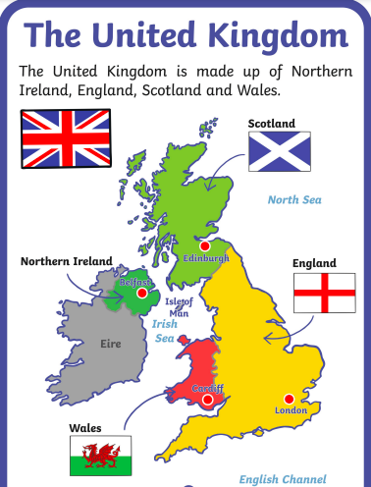
Our new enquiry question for the Spring term is “What lies beyond?”. We will be learning about the four countries that make up the United Kingdom and where they are located on the map.

We will be looking at the characteristics of England, Scotland, Wales and Northern Ireland. There will also be a focus on the capital cities within these countries.

We will be linking our enquiry to our learning in art by looking at the colours used within the England, Scotland, Wales and Northern Ireland flag. The children will be identifying both the primary and secondary colours used within the flags. We will be using different tools within our art to recreate each flag.

Our English lessons will also be linked to our enquiry question. To start the term, our writing lessons will involve writing a recount of our hook afternoon. This term we are continuing to focus on our handwriting, capital letters and full stops alongside our learning.

In maths we will be starting a unit on numbers to 20. We will then be focusing on addition and subtraction within 20, numbers to 50 and length and height.

Our PE lessons will continue to be on a Tuesday and Friday afternoon so please ensure your child is coming to school dressed in an appropriate PE kit.

As always, if you have any questions or queries do not hesitate to contact me either on class dojo or on the door.
Miss Jenkins

