Year 5
Summer Home Learning

Remember for every piece of homework you complete; you will be awarded 5 class Dojos!
Your home learning work will be based around our enquiry question:
Invasion: problematic or peaceful?
Enquiry | Imagine you were an Anglo-Saxon, write about what your life was like – you can choose to be whatever role you wish to be, a King, a warrior, a farmer. It’s your choice! | Explain why Sutton Hoo is so important.  What is it and how does it give us an insight into Anglo-Saxon life?  You can choose how you wish to present your information. | 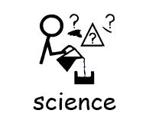  Carry out the separating solutions investigation.  See information below.
Research | Some of what we know about the Anglo-Saxons comes from the work of a priest called Gildas.  Found out all you can about Gildas and explain why we don’t have many sources of information from that time. | Find out what life was like for women and children during Anglo-Saxon times.  What were their roles? How was life different for men and women? How were children treated according to their gender? | Research religion during Anglo-Saxon times.  The Anglo-Saxons followed Pagan religions, but over a period of time Christianity became central to their way of life.  Explain what this means and how it happened.
Creative | Make a model or create a piece of artwork depicting an Anglo-Saxon or Viking ship. | Read the information below, about illuminated letters; you may wish to do some research into how they were created and what they looked like.  Now, write your name using illuminated letters. | Research and show what clothes were worn by different people during Anglo-Saxon times.  You may wish to choose contrasting people, for example, a warrior and a woman.
On-line  Activities | Each week please make sure you:  - Complete any Purple Mash 2dos that have been set.  - Spend some time on Spelling Shed.  - Practise your times tables on Times Tables Rock Stars.  - Read at least 3 times, either your own book, a school book or one of the books on Collins E-library.  Please tell me if you have completed all of the books on your E-library account and I will allocate some new ones for you.

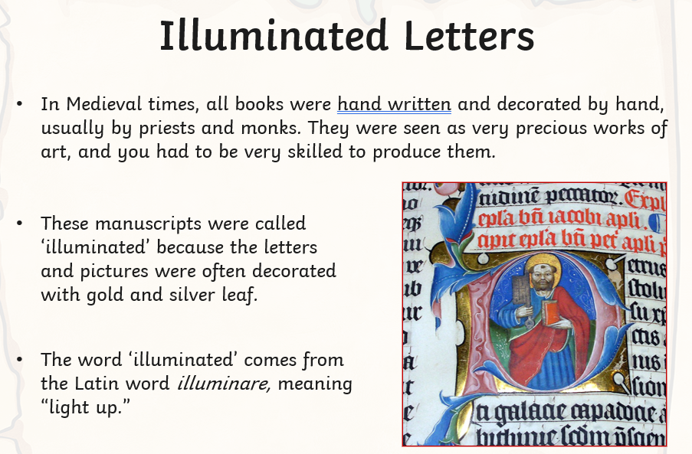

Separating solutions investigation


