Year 4 Autumn Newsletter
Welcome back Year 4! I hope you all had a lovely summer holiday and are ready and excited for the new school year in your new classroom! I am looking forward to the term ahead and to start our learning for our new enquiry. In Year 3, you learned all about the Stone, Bronze and Iron Ages. This term we will be learning about what happened after the Iron Age with the invasion of the Romans.
Our enquiry question this term is:
How has the past shaped us?

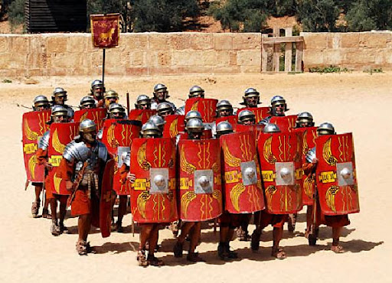
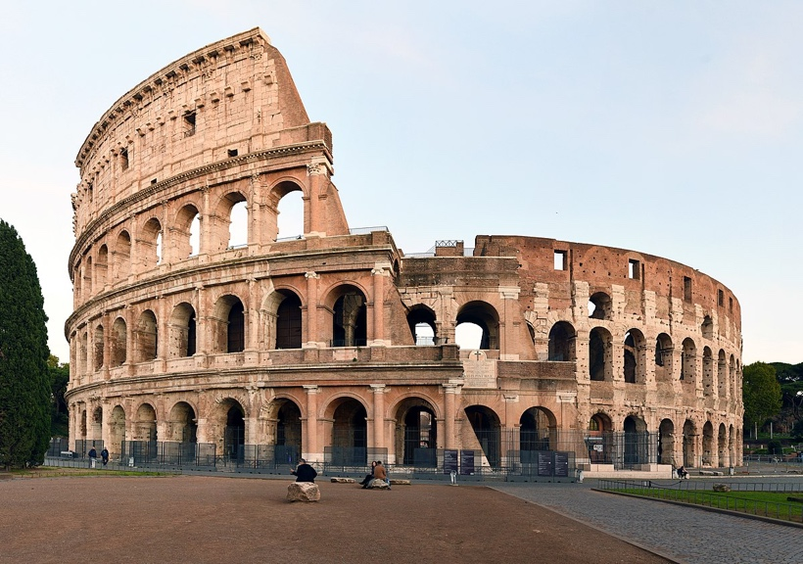
This term, all our learning will be based around our enquiry question. In History we will be looking at the Roman Empire, looking at the Roman invasion of Britain, the rebellion led by Boudicca and what influences the Romans had on Britain. In Science we will be learning about electricity and electrical circuits, we will also be linking this to some of our DT work where we will be making a product that uses an electrical system.
In Art we will be analysing Roman sculptures and then creating our own mini versions.
In our English lessons we will be writing a range of genres, including writing a letter to Emperor Claudius to apply for the Roman army, as well as a biography about Boudicca.



In Maths we will be moving onto four-digit numbers up to 10,000 and learning how to add and subtract them.
Year 4 is an important year for times tables with the Times Table Check happening in the summer term. It is important to regularly practise your times tables and use TimesTable Rockstars as often as you can!



Reading Journals
Please ensure you are reading with your child at home at least three times a week if possible, regular reading will improve your child’s reading skills. Recording when they have read at home in their reading journals means I can see how much they have been reading at home.

Our PE lessons are going to be on a Tuesday morning. Please make sure your child arrives at school on a Tuesday wearing their PE kit.

Please feel free to contact me if you have any questions or concerns through ClassDojo or in your child’s reading journal.

Class Teacher Headteacher
Miss Needham Mrs Smith

